# **Java Notes**

1. **Operators** 
   1. **Arithmetic operators**
      * + 🡪 Addition operator
      * - 🡪 Subtraction operator,
      * * 🡪 multiplication operator,
      * / 🡪 division 🡪 will return quotient
      * % 🡪 modulus operator 🡪will return remainder.
   2. **Assignment operators (=)**

int B=10;

Right hand side value will be assigned to left hand side.

* + 1. **Compound Assignment Operator**

+=, -=, /=, *= ,%=

a=6 // initialization statement or instruction

a+5 // arithmetic expression

a = a+5 🡪 a+=5 // arithmetic statement

class ArithmeticOperators

{

public static void main(String args[])

{

int a=10, b=3;

// Arithmetic Operators

System.out.println(a+b); //1. 13

System.out.println(a-b); //2. 7

System.out.println(a*b); //3. 30

System.out.println(a/b); //4. 3

System.out.println(a%b); //5. 1

// Assignment and compound Assignment Operator

a=a+5; // = is the assignment operator --> a=10+5 = 15

System.out.println(a); //6. 15

a+=5; // += is the compound assignment operator i.e

// first it will add and then assign.--> a= 20+5= 25

System.out.println(a); //7. 20

}

}

* 1. **Relational operators or Comparison Operators**
     + Used when you want to compare two data
     + Return always boolean value either true or false
     + <, >, <=, >=, ==, !=
     + < 🡪 less than 55<10
     + > 🡪 greater than 6>1
     + <= 🡪 less than or equal to 3<=2
     + >= 🡪 greater than or equal to
     + == 🡪equal to
     + != 🡪 not equal

Ex: 5<7 🡪 true

Ex: 10>15🡪 false

5<7 🡪 relational expression

boolean c = 6>10 🡪 relational statement

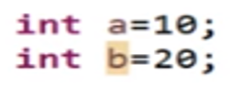

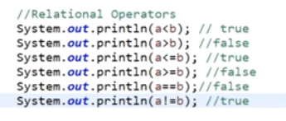

* 1. **Logical operators or Conditional operators**
* Used when we want to check more than one comparison at a time
* Return always boolean value either true or false
* &&, ||, !
  + - &&-->AND operator à * 🡪 5>10 && 4<10 🡪F && T🡪 0*1🡪0🡪F
    - ||--> OR operatorà+🡪5>10 || 4<10 🡪 f || t 🡪 0+1🡪 1🡪 true
    - !--> NOT operator🡪 it will take opposite value. True means false. False means true.

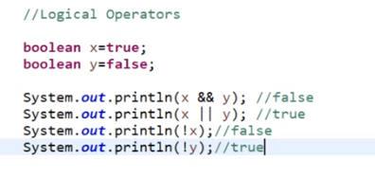

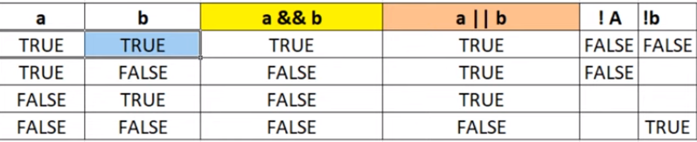

* 1. **Unary Operators**

***Unary operator 🡪 ++, --***

* ***Operator which work on single operand. It is an arithmetical operator***
* ***(++):- Increment operator***
* ***(--):- Decrement operator***

***These are again classified in 2 types***

* ***Pre increment: ++i (first increment and then use)***
* ***Pre decrement: --i (first decrement and then use)***
* ***Post increment: i++ (first use and then increment)***
* ***Post decrement: i-- (first use and then decrement)***
* package javabasics;
* public class UnaryOperator {
* public static void main(String[] args) {
* int a=5, b=15, c=10, d=20;
* System.***out***.println(++a); //6
* System.***out***.println(--b);//14
* System.***out***.println(c++);//10
* System.***out***.println(d--);//20
* System.***out***.println(c); //11
* System.***out***.println(d); //19
* }
* }

**Output:**

6

14

10

20

11

19

* 1. **Operator precedence in java**

<https://www.javatpoint.com/java-operator-precedence>